**R Code for Examples in the book**

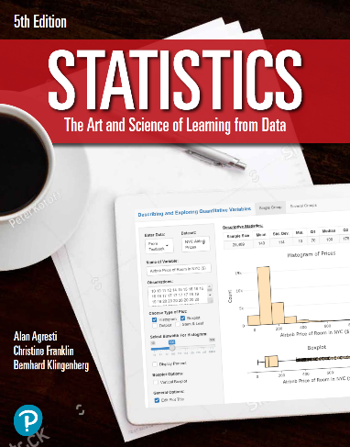

***“Statistics: The Art and Science of Learning from Data”***

**by Agresti, Franklin and Klingenberg, 5th edition**

**Chapter 6**

**Example 11: Test Scores that Use Different Scales – Comparing z-Scores**

## Reading in SAT data

meanSAT <- 500  
sdSAT <- 100

## To compute the z-Score of an SAT score of 650

zSAT <- (650 - meanSAT) / sdSAT  
zSAT

## [1] 1.5

## Reading in ACT data

meanACT <- 21.0  
sdACT <- 4.7

## To compute the z-Score of an ACT score of 30

zACT <- (30 - meanACT) / sdACT  
zACT

## [1] 1.914894